Safe Winter Walking Resource Information
Physical activity throughout the year is a part of healthy aging and can help prevent falls and fractures. Please feel free to use this content to develop your own local resources.
Top Tips for Winter Walking:
- Be prepared with reflective gear, warm clothing, and non-slip footwear.
- Have your eyes checked yearly. Give your eyes time to adjust to the change in light going from outdoors to indoors.
- Be aware of and take extra precaution when walking over ice, wet leaves, rain, and snow. Try to walk on clear paths, ask for help, or choose a different route.

During the winter months, many factors can cause a slip, fall, or injury such as fracture. Be safe this winter with these tips and tricks.
Physical activity is an important part of healthy aging. Walking is just one winter activity to get you moving! Regular physical activity during the winter months could include walking, snow shoeing, or shoveling. Get creative and have fun this winter! It is important to be prepared for winter walking conditions. Many things can impact your safety while you walk including footwear, balance, medication, distractions, and environmental factors such as temperature and snowfall.
Benefits of walking:
- Improves mental, social, and physical health; balance, posture, muscle strength.
- Reduces the risk of heart disease, developing high blood pressure, diabetes, and improves bone health to reduce the risk of fractures from falls.
- A good way to spend time with others
Before walking:
- Monitor the forecast and plan ahead. Dress in layers so you are prepared for changing winter weather. Stay warm by wearing a hat, scarf, and gloves.
- Wear bright or reflective gear so you can be seen by drivers, cyclists, and other walkers.
- Choose warm, stable footwear -- look for well-insulated and lightweight footwear with a
non-slip tread sole.
- Consider a cane or walking poles, use ice grippers on footwear and assistive devices when outside.

During your walk:
- Be aware of your surroundings and scan for hazards. Black ice is often not visible to the eye.
- Watch for ice, cracks, and uneven or changing surfaces. Be safe! Walk on designated, and clear paths. Try walking with a friend. Take your time and ask for help if needed.
- Keep your hands out of your pockets to help stay balanced.
- Give time to let your eyes adjust when going from outdoors to indoors or vice versa.

After you walk:
- Assess how you feel. If you are sore, switch to shorter walks and gradually increase your walking time.
- Enjoy a glass of water. Dehydration can make you dizzy, which increases the risk of falling. Drink 6-8 glasses of water each day to stay hydrated.
Helpful Tips:
- Keep your doctor informed of your physical activity level. Medication could increase your risk of falling!
- If you find yourself walking on ice, move slowly and think about your next move. Keep knees loose, shorten your strides, and shuffle your feet. Wet leaves, rain, and snow drifts can be as risky as ice.
- Once it gets dark outside, you may not be able to see dangers as easily - and dangers such as cars may not be able to see you. Be aware and wear reflective clothing if out at night.
- Take extra care when stepping off the last step of stairs. This is a common place for a fall. Use the hand rail when available for extra support.

Enjoy winter walking and be safe!

This resource was developed as a collective effort by the Southwest Region (Ontario) Falls Prevention Network (SWRFPN) and may be reproduced for other winter walking fall prevention resources.

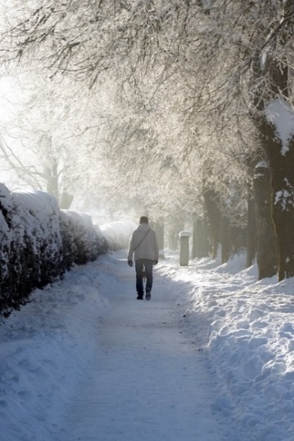
Resources
Canada Safety Council: Canada's Voice and Resource for Safety. Safety Tips for Winter Walking. https://canadasafetycouncil.org/senior-safety/safety-tips-winter-walking
My Health. Alberta.ca. Winter Walking Tips: Lower Your Risk of Falling.
https://myhealth.alberta.ca/Alberta/Pages/winter-walking-tips.aspx

Board of Health. Preventing Injuries from Wintertime Slips and Falls in Toronto. City of Toronto: Board of Health; 2016 Oct. Report No: PW17.14 Available from:
http://www.toronto.ca/legdocs/mmis/2016/pw/bgrd/backgroundfile-98004.pdf

University of Calgary. Risk - Environmental Health and Safety. Safe Winter Walking.
https://www.ucalgary.ca/safety/home/report-accident-incident-oars/safe-winter-walking

PEO Canada. 9 Winter Safety Tips You Didn’t Know.
http://www.peocanada.com/peo-blog/9-winter-safety-tips-you-didnt-know/

